**LP3 (Test on Edge Browser)**

**1.Verify the Header-**

(a) Logo should redirect to the correct link.

Yes, it is redirect to the link but not redirected to the correct link.

(b) Logo link should open in a new tab.

Yes, it is open in the new tab, but it is redirected to the same webpage.



**2.Verify the Footer-**

(a) Verify redirection of Links and content.

All the given contents and links is open in the new tab but it is redirect to the same page only.

(b) Verify social icons' redirection.

There is no social icon in the footer of the webpage.

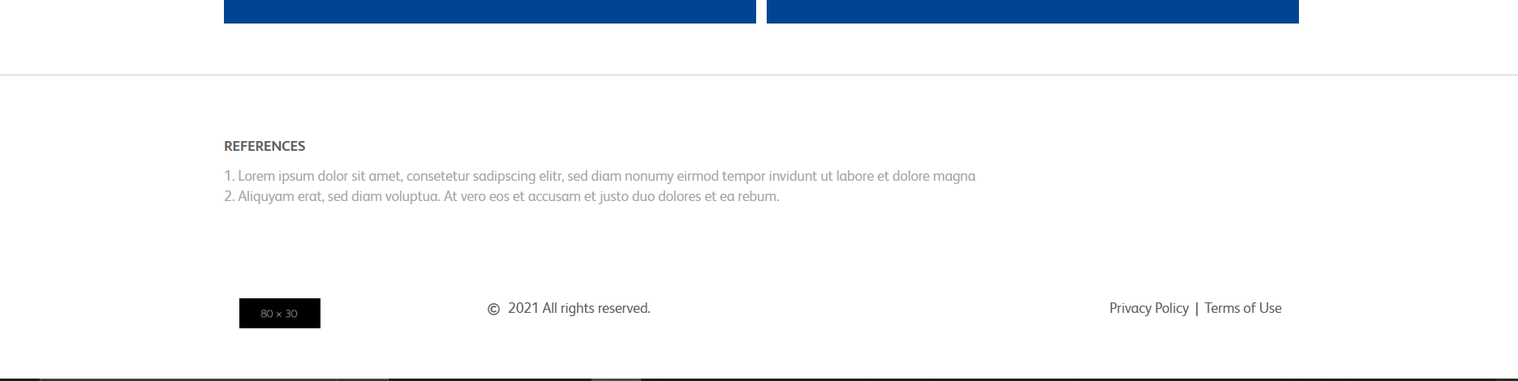

**3.Verify Correct Favicon- Favicon should be the same as it is on the client's live website.**

No favicon in the given link or webpage.

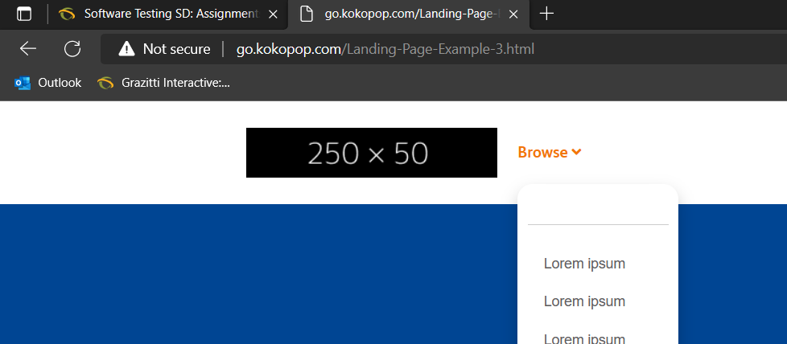

**4.Verify the Font-family- Verify font family is consistent throughout (unless special   requirement by client).**

Font is correct but the font color is too light making it dark color because it is easy to read the content of the webpage facing.

**5.Verify the redirection of links-**

(a) All CTAs, links and icons should redirect to correct pages.

All CTAs will be redirect given page only, it is not redirected to another page and the link or logo of footer and header is working but redirect to same webpage.

(b) Add note to developer if # is used for links.

Remove ‘#’ from all the links of CTA and icons.

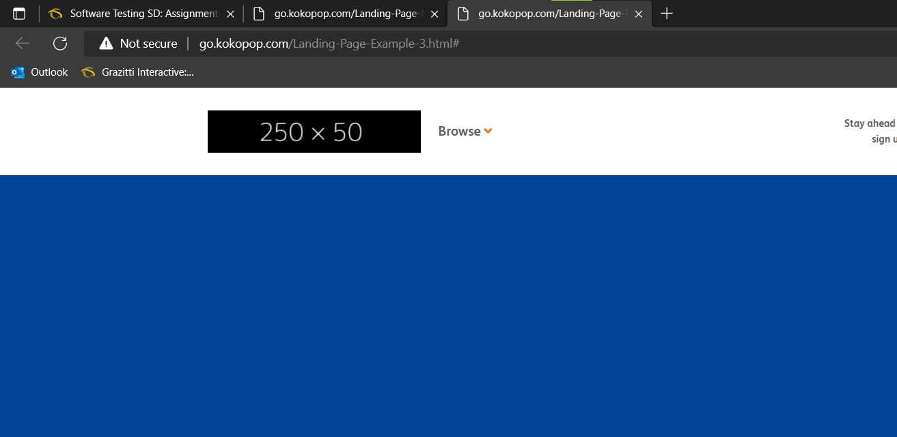

**6.Verify the Spacing - Verify Spacing and alignment of the page should not break.**

The banner size is too big and the spacing is too much in the below snapshots which is attach below.

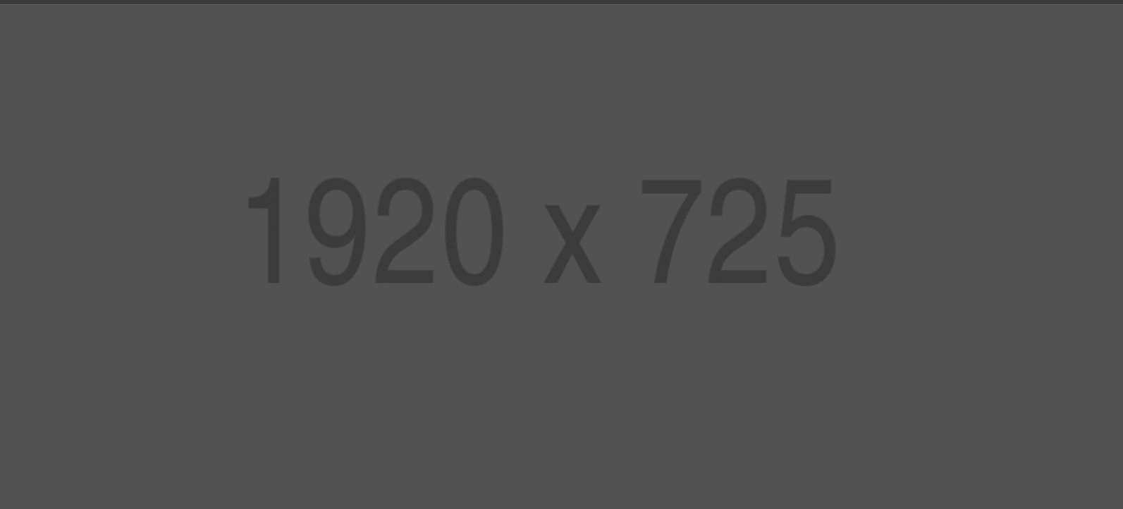

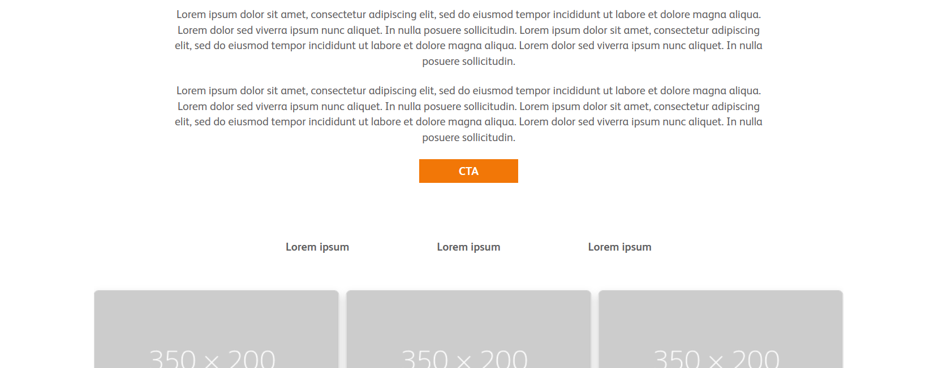

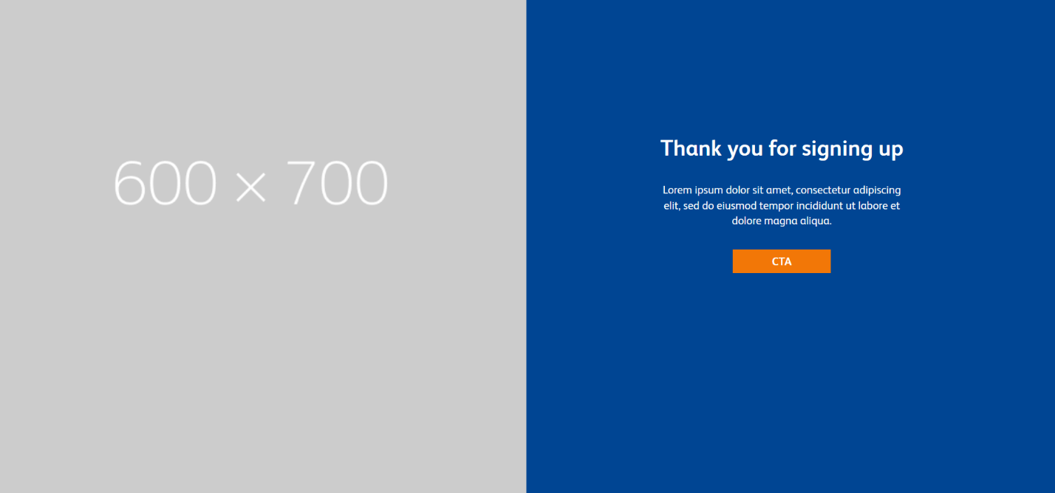

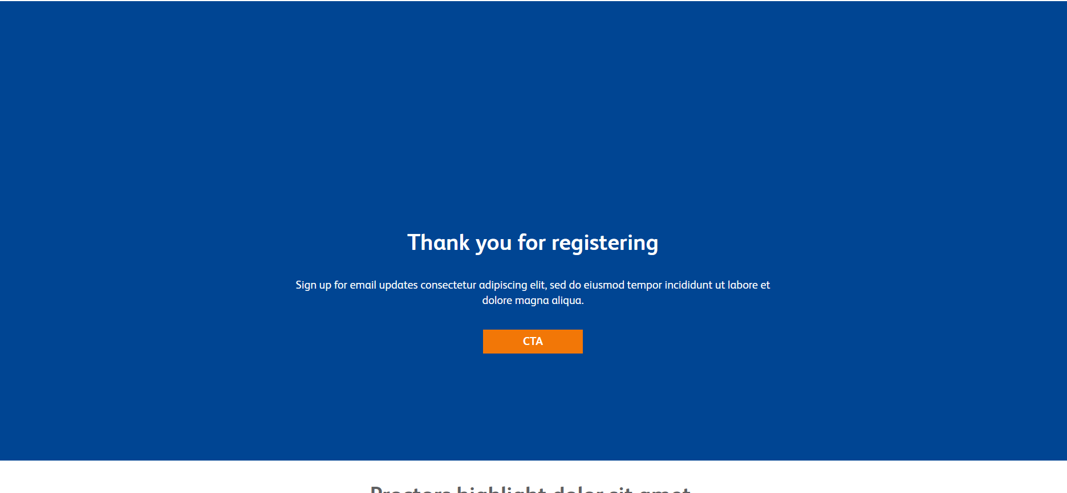

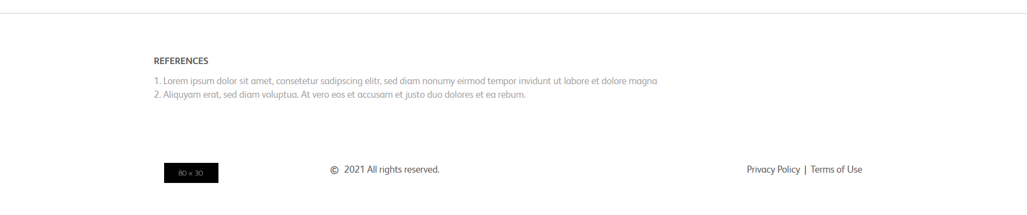

**7.Verify Form-**

(a) Verify alignment and spacing of form.

Alignment and Spacing of the form are correct.

(b) Verify * is used for Mandatory Fields.

It is not Mandatory field for the given form.

(c) Verify it is showing correct error messages.

Not showing any error messages.

**8.Verify Thank you message after submitting form- If Required.**

When we click on SUBMIT button, there is no pop-pop message is shown like Thank you, but there is an option in the bottom of the page, where we can see the Thank You message or see You are successfully registered.

**9.Verify Landing page on cross browsers- Google Chrome, Firefox, Internet Explorer and MAC (Safari).**

Working in Google, Chrome, Edge and Firebox

**10.Verify Responsive- Verify it on iPhone and iPad on simulator or live device.**